The Isle of Gigha Heritage Trust

DRONE
OPERATIONS
POLICY

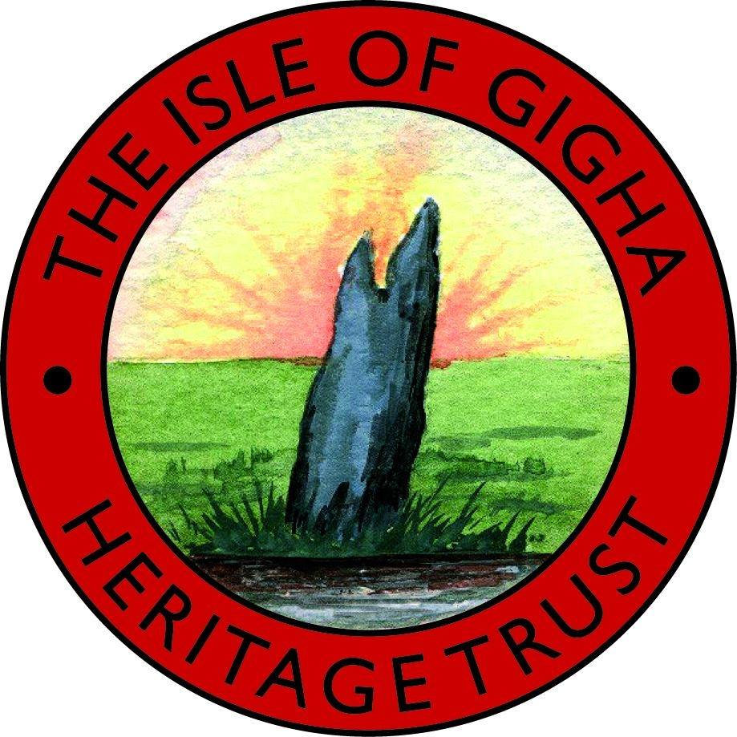

© The Isle of Gigha Heritage Trust - 2021
All rights reserved. Copies of this publication may not be reproduced for personal, company or organisational use without the expressed permission of The Isle of Gigha Heritage Trust.
This document is a combined Safety and Operations Manual, compliant with CAP722, covering all of aspects of The Isle of Gigha Heritage Trust utilising small drone aircraft in accordance with the requirements of the UK Civil Aviation Authority’s Permission for Commercial Operations.

Document Reference: Mavic 2 Pro
Version: 1:2 – 26 May 2021
Document Author: Andy Clements
Accountable Manager: Ian Wilson, IOGHT Chairman

Amendment Record

Version | Release Date | Amendments Incorporated | Initials

Acronyms and Abbreviations

Below is a list of abbreviations used in this Operations Manual;
Reference | Full Title
ATC | Air Traffic Controller
ATZ | Aerodrome Traffic Zone
CAA | UK Civil Aviation Authority
CTR | Controlled Traffic Zone
FRZ | Flight Restriction Zone
NQE | National Qualified Entity
PfCO | Permission for Commercial Operations
SUA | Small Unmanned Aircraft
VLOS | Visual Line of Sight

Commitment of Accountable Manager

This Operations Manual describes the organisation, aircraft systems, personnel, flight operations and procedures by which The Isle of Gigha Heritage Trust carries out its Small Unmanned Aircraft operations as a SUA Operator.
The Isle of Gigha Heritage Trust is committed to the safe conduct of all its Small Unmanned Aircraft operations and will ensure that the systems deployed are maintained and prepared in accordance with industry best practice, are operated in accordance with the procedures and bounds of this Operations Manual and within any limitation or condition specified in any UK Civil Aviation Authority (CAA) Permission granted for such aerial work.
It is accepted that the contents of this document do not override the necessity of reviewing and complying appropriately with any new or amended regulation published from time to time by the CAA addressed by this document.

Signed: |  | Date: | 26 May 2021
Accountable Manager: | Ian Wilson, IOGHT Chairman
SUA Operator | The Isle of Gigha Heritage Trust

For and on behalf of The Isle of Gigha Heritage Trust, is a company registered in Scotland (registered number: SC224141) and a Registered Scottish Charity (charity number: SCO 32302) Craft Workshop 1, Isle of Gigha, PA41 7AA
Tel: 01583 505 390, Email:office@gigha.org.uk

Enquiries regarding the content of this document should be addressed to The Isle of Gigha Heritage Trust at Craft Workshop 1, Isle of Gigha, PA41 7AA
Tel: 01583 505 390, Email:office@gigha.org.uk

Contents

Amendment Record 2
Acronyms and Abbreviations 2
Commitment of Accountable Manager 3
Contents 4
1 INTRODUCTION 6
1.1 Purpose 6
1.2 Scope 6
1.3 Overarching Strategy 6
1.4 Document Control and Amendment Process 6
1.5 Referenced Documents 6
2 SAFETY POLICY 7
2.1 Policy 7
2.2 Safety Management System 7
2.3 Safety Targets 7
3 ORGANISATION 8
3.1 Organisation 8
3.2 Identified SUA 8
3.3 Nominated Personnel 8
3.4 Responsibilities 9
3.5 Areas of Operation 9
3.6 Types of Operation 9
3.7 Supervision of SUA Operations 10
3.8 Accident Prevention and Flight Safety Programme 10
3.9 Flight Team Composition 12
3.10 Qualification Requirements 12
3.11 Logs and Records 12
3.12 Operator Training Programmes 12
3.13 CAA Permission 12
4 OPERATION……………………………………………………………………………………………………13
4.1 Role Training and Currency 13
4.2 Area of Operation 13
4.3 Operating Limitations and Conditions 13
4.4 Methods to Determine the Intended Tasks and Feasibility 13
4.5 Operating Site Planning and Assessment 14
4.6 Communications 14
4.7 Site Permissions 15
4.8 Weather 15
4.9 Night Time Operations 15
4.10 On Site Procedures 16
4.11 Assembly and Functional Checks 16
4.12 Take-Off Checks 16
4.13 Flight Procedures 16
4.14 Post Flight and Between Flight Checks 17
4.15 Emergency Procedures 17
APPENDICES 18
Appendix A – Insurance Certificate 18
Appendix B – Manufacturer’s SUA Technical Specification 19
Appendix C - Logbooks 20
Appendix D - Permission for Commercial Operations 25
Appendix E – Flight Planning and Risk Assessment Forms 27
Appendix F –Flight Reference Cards and Checklists 33
Appendix G – SUA Emergency Procedures 38

INTRODUCTION

Purpose
The purpose of this document is to record the key data associated with the safe operation of any Small Unmanned Aircraft (SUA) with a Maximum Take-Off Mass of up to 20 kg by The Isle of Gigha Heritage Trust personnel.

Scope
The Isle of Gigha Heritage Trust’s traditional business is charitable organisation.Its customer base is the Gigha Community, managing and running the Island of Gigha.

Overarching Strategy
The Isle of Gigha Heritage Trustis to support land management, for example documenting field conditions prior to new tenancies and any improvements undertaken. The drone will also assist with a number of other activities such as: investigations on height related faults; surveys of external issues of the turbines; and also to evaluate and monitor development projects on the island such as Achamore Gardens – where progress on the restoration can be documented. The images produced will also be used in new marketing and promotion of these projects.
Safety is paramount. The Isle of Gigha Heritage Trust has put essential safeguards in place to maintain a safe environment for all involved or connected to The Isle of Gigha Heritage Trust SUA operations.

Document Control and Amendment Process
All amendments to this Operations Manual will be made by Andy Clements and will be recorded in the Amendment Record Page found at the front of this document. Each amendment is identified with a new Version Number, an Amendment Date, and a list of the major Amendments Incorporated. All amendments will be signed off by the Accountable Manager, Ian Wilson, IOGHT Chairman.
The CAA will be informed of all major updates such as new aircraft or pilots. Major updates are recognised in the Version Number of this Operations Manual through increments in the whole number: minor updates are registered by decimal increments.
All those engaged on SUA operations by The Isle of Gigha Heritage Trust will be kept informed of any changes to this Operations Manual.

Referenced Documents
Reference | Full Title | Version & Date of Issue
CAP 382 | Mandatory Occurrence Reporting Scheme | Tenth Edition – December 2016
CAP 393 | The Air Navigation Order 2016 and Regulations | Version 5.6 – 13 March 2019
CAP 722 | Unmanned Aircraft System Operations in UK Airspace– Guidance | Seventh Edition, amendment 2019/03, 4 September 2019
CAP1763 | Air Navigation Order 2018 and 2019 Amendments - Guidance for Small Unmanned Aircraft Users | Version 2 – 20 February 2019

SAFETY POLICY

Policy
Safety is the first priority in all The Isle of Gigha Heritage Trust SUA operations. The business is committed to implementing, developing and improving strategies, management systems and processes to ensure that all its aviation-related activities uphold the highest level of safety performance and meet national and where appropriate international standards.
The Isle of Gigha Heritage Trust’s commitment is to:
- Comply with and, wherever possible, exceed legislative and regulatory requirements and standards;
- Clearly define for all those engaged on SUA operations their accountabilities and responsibilities for the development and delivery of the company’s aviation safety strategy and performance;
- Minimize the risks associated with aircraft operations to a point that is as low as reasonably practicable and achievable;
- Ensure that sufficient skilled and trained resources are available to implement the stated safety strategy and policy;
- Establish and measure safety performance against realistic objectives and/or targets;
- Continually improve its safety performance; and
- Conduct safety and management reviews and ensure that relevant corrective action is taken.
- Ensure that all staff are provided with adequate and appropriate aviation safety information and training, are competent in safety matters and are only allocated tasks commensurate with their skills;

Safety Management System
The Isle of Gigha Heritage Trust has only implemented the rudiments of a full Safety Management System.
The ‘internal’ Safety Objectives are:
• Encouraging an environment whereby safety has top priority and is second nature, and
• Increasing the knowledge on safe operations and practices on the part of its personnel and customers.

Safety Targets
It is the goal of The Isle of Gigha Heritage Trust to operate aircraft without harm, injury or damage to any persons or property.
The The Isle of Gigha Heritage Trust Remote Pilot will comply with all safety requirements and limitations of the Permission for Commercial Operations issued by the UK CAA to The Isle of Gigha Heritage Trust.
The safety target is No Accidents.

ORGANISATION

Organisation
SUA Operator: The Isle of Gigha Heritage Trust
Organisation Type: Registered Scottish Charity (charity number: SCO 32302
Organisation Registration Number: SC224141
Country of Registration: Scotland
Operator ID: OP-QCCXY33
All drones operated by The Isle of Gigha Heritage Trust are labelled with the Operator ID.
The Isle of Gigha Heritage Trust has third Party Public Liability Insurance as outlined below:
Insurer: NFU
Insurance Policy Number: B1262FSA0000920/8885
3rd Party Liability Insurance: £1,000,000
Insurance Expiry Date: 14/03/22

A copy of the current Certificate of Insurance is enclosed as Appendix A to this Operations Manual.

Identified SUA
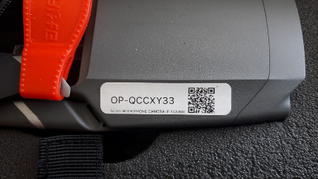
The Isle of Gigha Heritage Trust flies the following SUA:
SUA #1: DJI Mavic Pro 2
SUA Type: Multirotor
SUA MTOM: >2kg
SUA Serial No.: 163CG9LROA1ZLO

The manufacturer’s technical specification for this DJI Mavic Pro 2, SUA is attached as Appendix B.

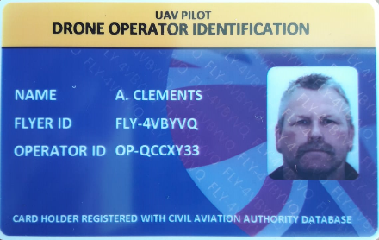
Nominated Personnel
Remote Pilot: Andy Clements
Flyer ID: FLY-4VBYVB
Position held: Housing & Estates Manager
SUA Type: Multirotor
SUA Weight Category: 0 - 20 kg

Responsibilities
The Remote Pilot’s responsibilities are:
- Communicating with Householders/Farmers as required to understand the required task.
- Planning each flight in advance and ensuring the right resources are available when required.
- Supervising each operation of the SUA.
- Completing the pre-flight risk assessment and mitigating any risks where possible.
- Having confidence that the flight can be conducted safely and the competence to perform that flight.
- Checking that everything is secure on the SUA.
- Ensuring that the aircraft used is airworthy by completing the pre-flight checklist.
- Briefing all other attending staff prior to a flight to ensure they understand their responsibilities.
- Ensuring that the welfare of themselves or others is not compromised by any planned operations.
- Operating the aircraft within the stated limitations for that aircraft.
- Respecting the limitations stated on the Permission for Commercial Operations.
- Ensuring that he or she is of sound body and mind to operate the aircraft.
- Completing all required paperwork such as pilot & aircraft hours, battery log etc. after a flight.

Areas of Operation
The anticipated areas of operation is restricted to the Isle of Gigha.
If the operating site is within an ATZ or a CTR in Class D airspace, and especially if within the Flight Restriction Zone (FRZ) of a ‘protected aerodrome’, as defined by CAP393, the Air Navigation Order and Regulation 2016 version 5.6, the Remote Pilot will contact the appropriate ATC for advice and clearance to fly.
Where the planned operation is within 5km of an airfield, protected or otherwise, the Remote Pilot will seek to contact the resident ATC or the airfield operator as a courtesy.

Types of Operation
The anticipated types of operation are:
- Aerial Photography
- Aerial Videography
- Building Inspection
- Land Survey
- Turbine inspections
All operations will be conducted within standard Visual Line of Sight (VLOS) limitations of 400 ft above surface level and at a maximum distance from the Remote Pilot of 500 metres provided the Remote Pilot can see the Small Unmanned Aircraft (SUA) in good Visual Meteorological Conditions.
The minimum separation from individual people, vessels or vehicles not directly under the control of the Remote Pilot will be 50 metres. The same distance will be maintained from structures not under the control of the Remote Pilot.

Supervision of SUA Operations
The Remote Pilot present during each operation will be responsible for the supervision and safe conduct of that operation.
The Remote Pilot will seek clearance from the Accountable Manager in advance of a flight where a risk is identified as not being in the Low or Moderate categories and cannot be easily mitigated.
An Observer, if present, will be charged with pointing out to the Remote Pilot any unobserved threat or risk that manifests itself during a flight using instructed and trained scan techniques.
Any safety issue that arises will be brought to the attention of the Accountable Manager as soon as practicable after the incident has been recorded.

Accident Prevention and Flight Safety Programme
The Isle of Gigha Heritage Trust will comply with the requirements of CAP382, Mandatory Occurrence Reporting.
Any Incidents or Occurrences occurring ‘in flight’ will be dealt with by The Isle of Gigha Heritage Trust as follows:
Incident Handling
In the event of any Incident, the severity must be assessed. The following lists should help to identify Minor and Major Incidents:
MINOR INCIDENTS
- Any unusual or unexpected flight behaviour from the aircraft which does not result in damage or loss
- Any failure of any aircraft system which does not result in damage or loss
MAJOR INCIDENTS
- Any unusual or unexpected flight behaviour from the aircraft which results in damage or loss
- Any significant damage to the aircraft caused by an aircraft system failure
- Any significant danger or damage to persons, possessions or property during Flight Operations
- Any public encroachments or aircraft incursions which required preventative measures to avoid
Incident Logging
All MINOR incidents will be logged in the Aircraft Log as well as the The Isle of Gigha Heritage Trust Incident Log. Upon noting a minor incident, the logs should be checked for similar occurrences. If a similar minor incident occurs three times then an investigation will be initiated to identify the cause and consider implementing steps to reduce the likelihood of this incident occurring again.
All MAJOR incidents require an investigation as outlined in the Investigation Procedure section. The Incident Log should also be updated as to the outcome of any investigation.
Investigation Procedure
Any investigations undertaken by The Isle of Gigha Heritage Trust will follow the procedure shown below.
INTRODUCTION
The introduction contains the context for the Incident and confirms the major facts as to the companies and people involved, why they were present and the reason for the flights being carried out.
DESCRIPTION OF EVENTS
This is a factual account of the events leading up to and immediately after the incident as well as the incident itself. Its aim is to provide an agreed basis upon which the analysis is carried out.
Importantly any assumptions should be clearly stated and all data provided should have its authenticity and derivation stated. If there are doubts then these should also be clearly articulated so that future analysis can take this into account.
ANALYSIS
The analysis of events sets out to find explanations for what is described in the description of events. Wherever possible the analysis draws upon known concepts, models and physical understanding to ensure that the events as described have a logical explanation.
The analysis should set the scene for any conclusions and provide traceability from the facts to the conclusions in a logical and auditable way.
CONCLUSIONS
The conclusions are derived from the analysis, which themselves are based upon the facts in the description of events or the facts as they pertain to concepts, models and physical understanding exposed within the analysis. A strong conclusion is one where this traceability is good and can stand up to scrutiny.
RECOMMENDATIONS
The aim of the recommendations is to provide the organisations or personnel identified for the report with those items and actions that can lead to a safer operation and which address the short-comings highlighted through the investigation process.
Mandatory Occurrence Reporting
The UK Air Navigation Order states “Any incident which endangers or which, if not corrected, would endanger an aircraft, its occupants or any other person” is a reportable occurrence. CAP382 requires that a reportable occurrence is filed on the ECCAIRS European-wide reporting system on the Internet at http://www.aviationreporting.eu/AviationReporting/.
Incidents involving injury to a person should also be reported by The Isle of Gigha Heritage Trust to the Air Accident Investigation Branch by phoning 01252 512299.

Flight Team Composition
Remember operations in urban environments will need more crew members acting as marshals to help try and control the movement of people. For operations ‘within congested area’, i.e. you are surrounded by congested areas, it is strongly recommended that the minimum crew size is two with the second person on the crew being a Competent Observer.
When working alone, then clearly state you may operate alone, but will seek assistance where the risks may be greater or there are any safety concerns.

Qualification Requirements
The Isle of Gigha Heritage Trust Remote Pilot ha2 completed a Pilot Competency Assessment with the CAA.

Logs and Records
The Isle of Gigha Heritage Trust will maintain up-to-date information and operational logs for:
- Aircraft and Pilot Hours
- Aircraft Maintenance
- Incidents / Accidents
See Appendix C for examples of these logs.

Operator Training Programmes
All The Isle of Gigha Heritage Trust pilots acting as Remote Pilots on commercial drone operations will be subject to regular assessment by the The Isle of Gigha Heritage Trust Accountable Manager on an annual basis for competency and currency.
To maintain currency a Remote Pilot must have flown a SUA for more than 2 hours in the previous 3 months.
The Isle of Gigha Heritage Trust will also carry out an annual assessment and re-training of all those engaged on its SUA operations.

CAA Permission
A copy of the Permission for Commercial Operations issued to The Isle of Gigha Heritage Trust by the CAA is included in this Operations Manual as Appendix D.

ORGANISATION

Role Training and Currency
All The Isle of Gigha Heritage Trust Remote Pilots will have to hold a pilot competency assessment or other qualification recognised by the CAA for SUA commercial operations and will be assessed by the The Isle of Gigha Heritage Trust Accountable Manager as being knowledgeable and competent to fly The Isle of Gigha Heritage Trust’s SUAs in The Isle of Gigha Heritage Trust’s potential operating environments.
All The Isle of Gigha Heritage Trust Remote Pilots will be expected to maintain flying skills currency through hands-on flying with The Isle of Gigha Heritage Trust SUAs, other SUAs they have access to or appropriately-configured simulators.

Area of Operation
The anticipated areas of use will be restricted to The Isle of Gigha Heritage Trust owned land or with permission from owner of other properties/land on the island.

Operating Limitations and Conditions
All The Isle of Gigha Heritage Trust operations will be conducted within the limitations stipulated within CAP393 Articles 94 and 95, version 5.6, and CAP722 or as updated in the PfCO issued by the CAA to The Isle of Gigha Heritage Trust.
The standard limitations are:
- Visual Line of Sight (VLOS) in accordance with CAP393 Article 94
  - To a maximum vertically above surface of 400’
  - Up to a maximum distance from the Remote Pilot of 500m
providing in both cases the pilot can identify and monitor the SUA
- Not over or within 150m of Open Air Assemblies of more than 1000 people (CAP393 Article 95)
- Not within 50m of People not under the control of the Remote Pilot of the SUA) although this distance is reduced to 30m during take-off and landing (CAP393 Article 95)
- Not within 50m of Vehicles, Vessels and Structures not under the control of the Remote Pilot (CAP393 Article 95)
- Not over or within the FRZ of a ‘Protected Aerodrome’ or other airfield without clearance and permission to fly from the resident ATC or airfield operator (CAP1763 and CAP393 Article 94B).
In addition to these legal limitations, The Isle of Gigha Heritage Trust has implemented its own operating limitations with its SUA and these limitations are listed in Section 3.3.

Methods to Determine the Intended Tasks and Feasibility
For all The Isle of Gigha Heritage Trust commercial drone operations, the designated Remote Pilot will assess the intended task using the Pre-Site Visit Formsee Appendix E. Details captured on the form will include:
- Contact Details
- Work Required
- Date and Time Constraints
- Location of Work (Latitude and Longitude if possible)
- Landowner or Land Occupier Details
- Other Nearby Air Users (if known)
- Types of Congested Areas present and other Groundspace uses
- Any Other Relevant Information
The completed Pre-Site Visit Research Form and the Site Survey Form will be retained for at least two years for future reference if required.
The designated Remote Pilot will be responsible for determining the method of operation for the intended task, identifying resources and assessing the task’s feasibility. If he or she has any reservations he will discuss the reservations with the The Isle of Gigha Heritage Trust Accountable Manager before proceeding with the task.

Operating Site Planning and Assessment
As part of the research into task feasibility, the The Isle of Gigha Heritage Trust Remote Pilot will use whatever tools and facilities deemed necessary and available to him. These may include:
- Client Information
- Current and Relevant Aeronautical Charts
- Integrated Aeronautical Information Package – United Kingdom
- SkyDemonLight or Sky Vector or Drone Assist App - Online Aeronautical Charts
- Dronesafe, in particular Airfield Flight Restriction Zones
- NOTAM info
- Ordnance Survey
- Google Earth
- Google Maps or Bing Maps
- Weather Forecasts
On some sites it may be necessary to implement Further Control Measures to mitigate some of the risks. In these cases, the Risk Mitigation Form in Appendix E will be used.
The task will only go ahead if the Remote Pilot is satisfied the necessary controls and safeguards can be put in place for a safe operation.

Communications
Contact telephone numbers for the following will be recorded on the Pre-Site Visit Research Form, and the Site Survey Form, which can be found in Appendix E, before departure to the site:
- Landowner or Land Occupier
- Observer and Crew
- Client
- Local Police Station
- Local Hospital
- Local Air Traffic Control (ATC)
- Local Air User Clubs
Where possible, contact will be made with the Landowner or Land Occupier before any physical site survey in conducted.

Site Permissions
The designated Remote Pilot will obtain permission from all relevant landowners or land occupiers over which flight operations are to be conducted. Where possible, permission will be sought in writing. Where it is available in writing a copy of the permission will be carried on site. No flight operations will commence without permission, either written or verbal, from the relevant landowners or occupiers.

Weather
In advance of any flight operation the designated Remote Pilot will obtain long, medium and short-range weather forecasts. Twenty-four hours before the proposed flight operations the Remote Pilot will determine whether the planned flight operations will go ahead.
Weather and other forecasts, such as solar activity, will be obtained using readily available resources, which may include:
- UAV Forecast
- XC Weather
- Weather Channel
- BBC
- Met Office
- Weatherpro

Night Time Operations
If The Isle of Gigha Heritage Trust is reqired carry out a Night Time Operation, the The Isle of Gigha Heritage Trust Remote Pilot will determine whether a safe operation in accordance with the client’s requirements can be completed.
Before the operation takes place the The Isle of Gigha Heritage Trust Remote Pilot will carry out a full On-Site Survey in advance during daylight hours to identify the hazards present and the risks they present.
For the operation the The Isle of Gigha Heritage Trust Remote Pilot will arrange for the take-off and landing site to be suitably illuminated and for the SUA itself to carry an additional light so it can be identified easily whilst in flight.
For the purposes of Night Time Operations, Night Time is deemed to be more than 30 minutes after sunset until more than 30 minutes before sun rise.

Safer Night Time Operations are achieved by minimising height and the lateral distance travelled. If you are prepared to impose your own limitations, say a maximum of 200 ft agl and 100 metres distance

On Site Procedures
Before setting up on-site in accordance with the On-Site Arrival Checklist, see Appendix F, the Remote Pilot or a designated crew member will carry out the following measurements:
- Windspeed at surface level, using a handheld anemometer.
- Check with XC Weather
If the Remote Pilot feels confident that the proposed flight operations can be safely carried out, then the operation can progress to complete the On-Site Arrival Checklist.
Once set up on site, the Remote Pilot will then carry out the On-Site Survey, see form in Appendix E, to familiarise him or herself with the local geography of the site. This will be completed by physically walking around the site to identify any hazards and any identified will be marked on the On-Site Survey Form. Where an Observer is present, the Observer will accompany the Remote Pilot.
The Remote Pilot must be satisfied that all risks identified are acceptable before proceeding to the next stage

Assembly and Functional Checks
The SUA will be assembled and checked in accordance with the relevant SUA Assembly and Set Up Checklist, see Appendix F.
The Remote Pilot will check the day prior to the flight operation that all necessary software and firmware updates have been completed on the SUA to be flown and, if necessary, a test flight has been conducted.

Take-Off Checks
The SUA will be prepared for flight by the Remote Pilot following the Take-Off Checklist, see Appendix F.

Flight Procedures
During flight, the Remote Pilot will conduct situational updates with the Observer if present. Situational updates will include:
- SUA position and responsiveness
- SUA battery status
- Horizon scans and airspace assessments
- Landing site incursions
- Alternate landing site incursions
- Air incursions (air users / birds)
- Potential adverse weather changes
- Ground incursions, particularly those that might endanger the Remote Pilot
Prior to landing, the Remote Pilot will go through the Landing Checklist, see Appendix F.

Post Flight and Between Flight Checks
The SUA will shut down, made safe and checked in accordance with the Post Flight Checklist, see Appendix F.

Emergency Procedures
The Emergency Procedures for The Isle of Gigha Heritage Trust’s SUA are set out in Appendix G.

APPENDICES

Appendix A – Insurance Certificate
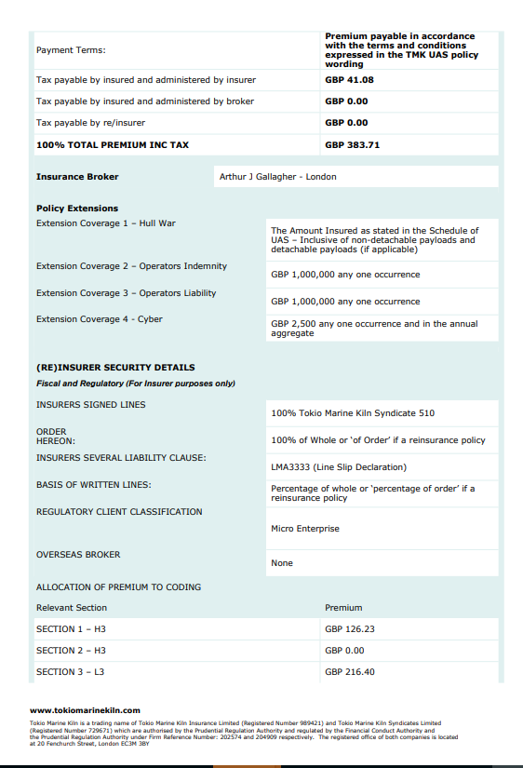
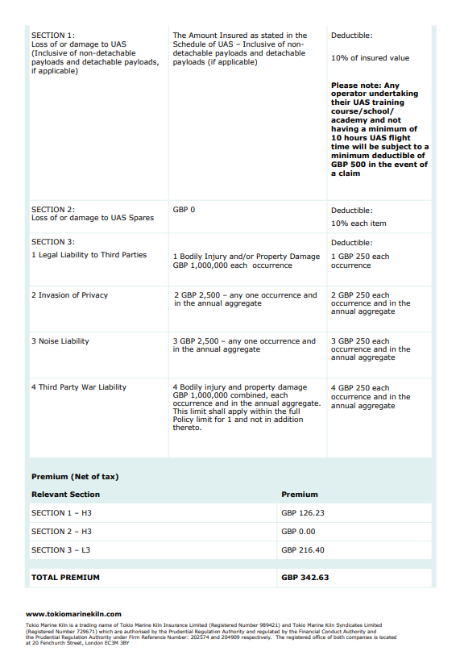
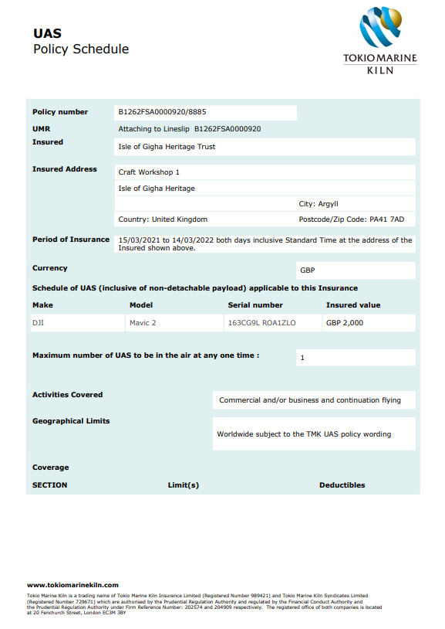

Appendix B – Manufacturer’s SUA Technical Specification

Copy available within Drone Folder held in The Isle of Gigha Heritage Trust Office.

Appendix C - Logbooks
C1. Pilot Log
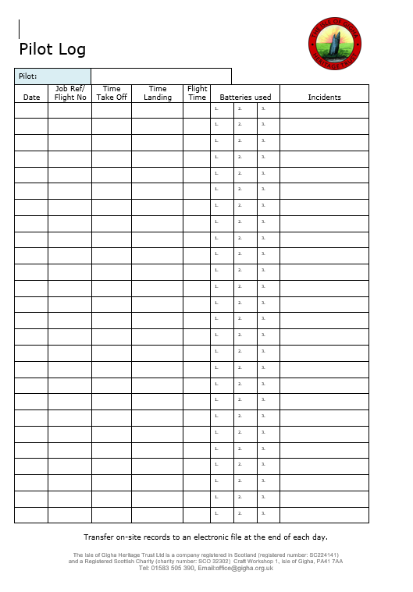

C2. Aircraft Log
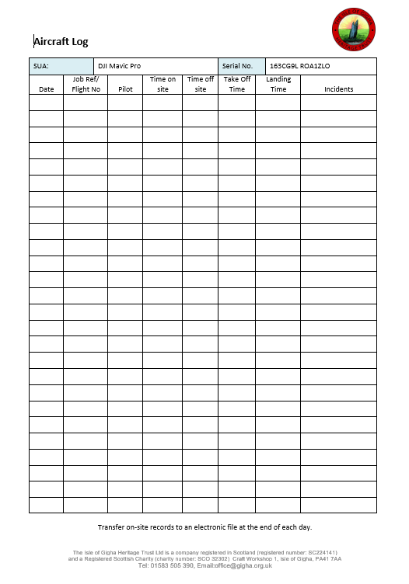

C3. Aircraft Maintenance Log
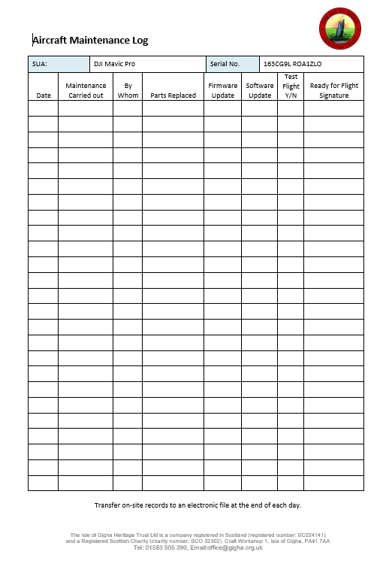

C4. Incident Log
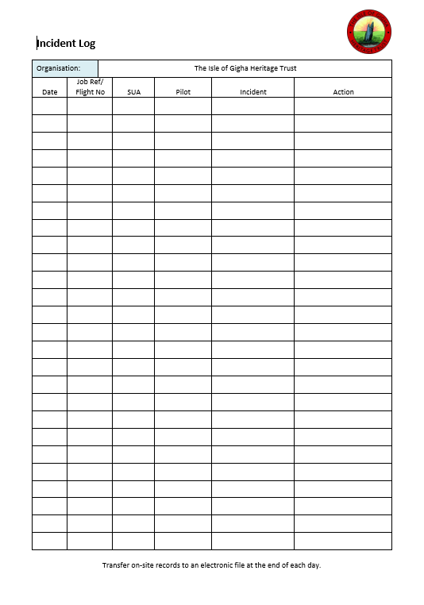

Appendix D - Permission for Operations

Appendix E – Flight Planning and Risk Assessment Forms

E.1 Pre-Site Visit Research Form
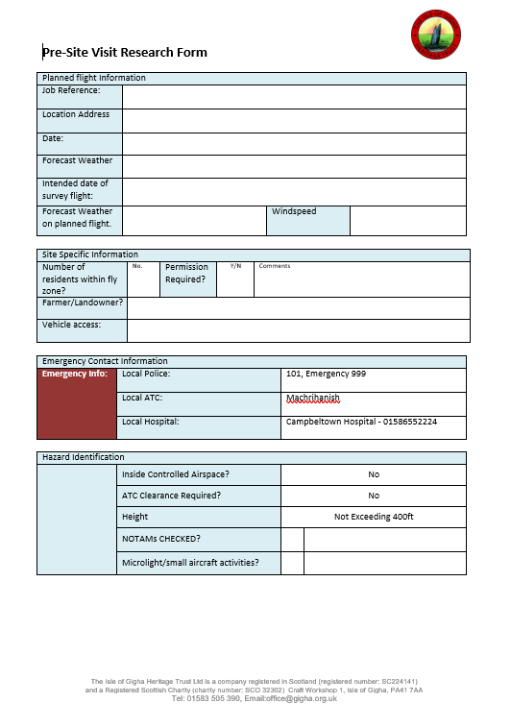
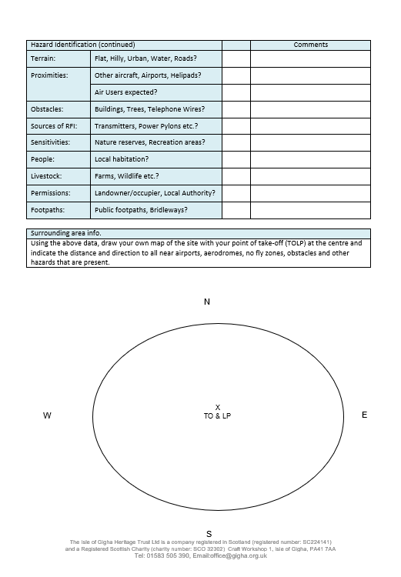
E.2 Site Survey Form
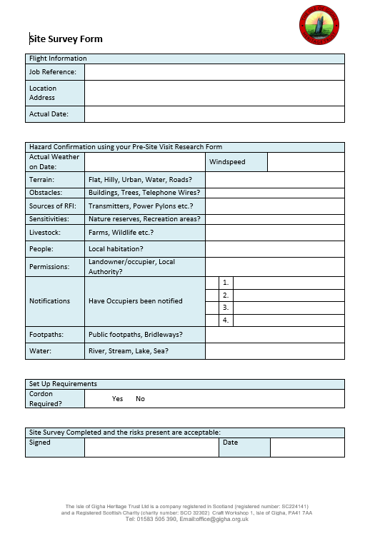
E.3 Risk Mitigation Form
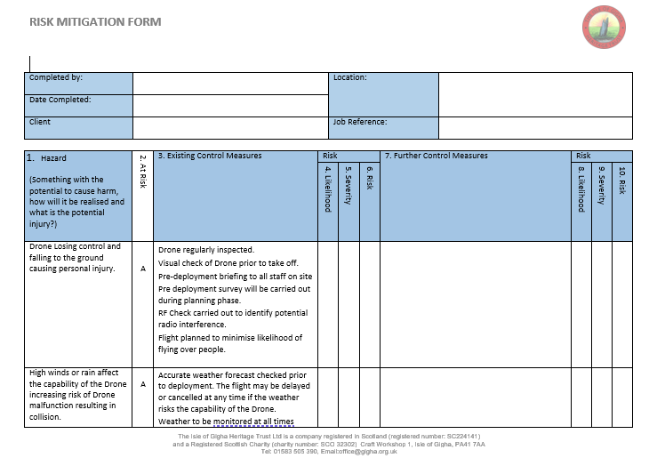
E.3 Risk Mitigation Form
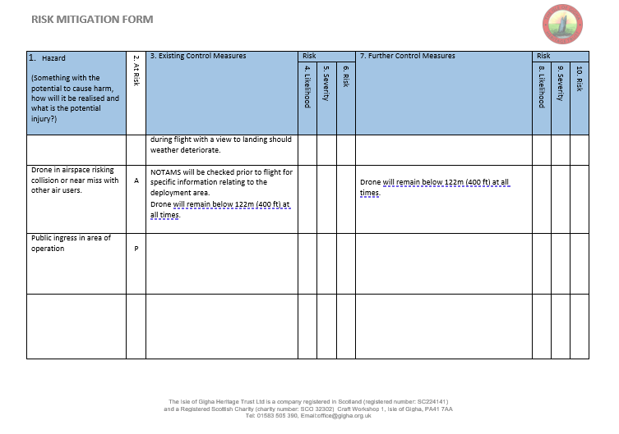
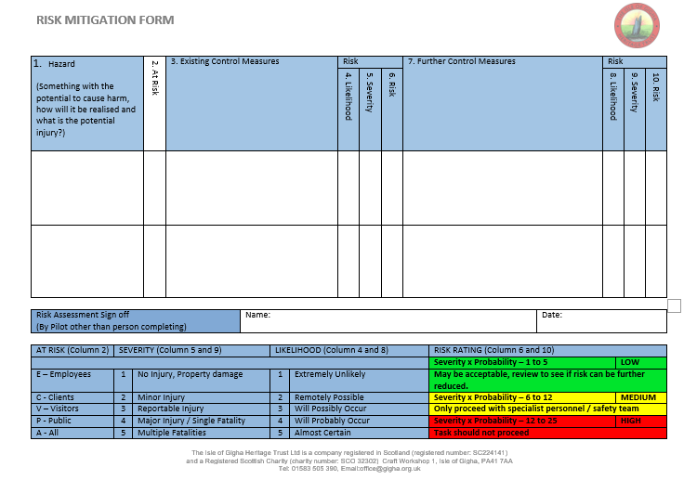

Appendix F –Flight Reference Cards and Checklists

F.1 Equipment Loading List

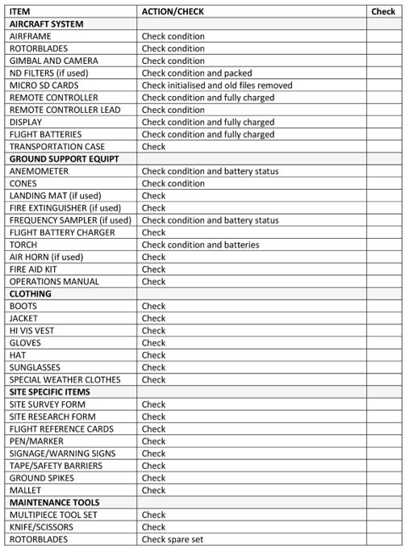

F.2 On Site Set Up Checklist

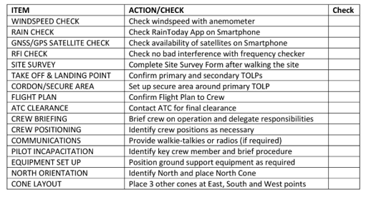
F.3 SUA Assembly Checklist

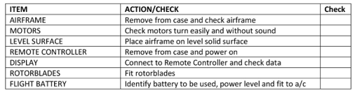

F.4 SUA Set Up Checklist

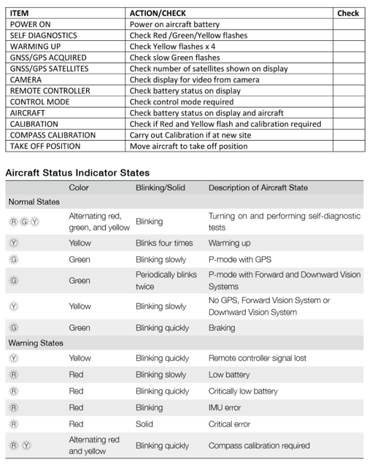

F.5 Pre-Flight Checklist

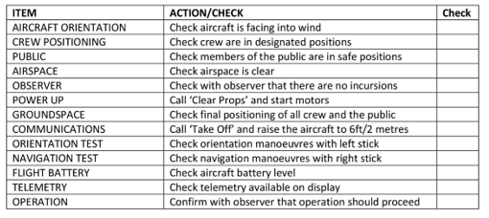
F.6 Pre-Landing Checklist

[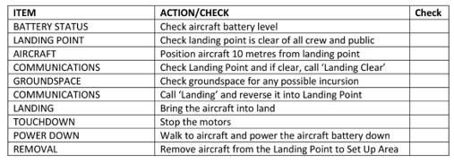

F.7 Post Flight Checklist

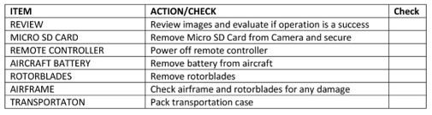

Appendix G – SUA Emergency Procedures

G.1 Pilot Incapacitation
Symptom/  Issue | Warning | Pilot Action | Crew Action | Remarks
Pilot incapacitation |  | Activate RTH (Return to Home) or BL (Back Landing) if possible. | Pick up controller.  Confirm launch area clear.  Monitor video display (if still functioning).  Initiate Return to Home procedure OR land the SUA if trained to do so.  Administer First Aid to pilot as appropriate  Call Emergency Services if required | Administer first aid to pilot.  When Return to Home is initiated: If below 20m the SUA will climb to 20m (if already above 20m the SUA will stay at the same height)  The SUA will return directly to the launch position, hover for 15 seconds then gradually descend until it lands and the motors will automatically disarm.  Complete CAP 382 MOR ECCAIRS.

G.2 Airspace Incursion
Symptom/  Issue | Warning | Pilot Action | Crew Action | Remarks
Airspace Incursion | Visible or audible signs of another air user in the location. | Climb or descend as appropriate.  Alert crew to issue.  When location of other air user has been identified move directly away, land if safe to do so. | Crew to prioritise the identification of the location of the other air user.  Crew to keep pilot aware of what they can see.  Ensure landing location is clear. | Record any relevant information relating to the airspace incursion for UK AirProx Board.  Complete AirProx Form CA1904

G.3 Loss of Control Data Link
Symptom/  Issue | Warning | Pilot Action | Crew Action | Remarks
Loss of Control Data Link | SUA unresponsive  Poor signal strength.  SUA shows fast flashing amber lights | Alert crew to issue.  Attempt to regain control of the SUA by changing flight mode from its current mode to an alternate and back. | Ensure landing location is clear.  Monitor video display (if still functioning).  Provide pilot with appropriate updates on status. | SUA will enter a ‘failsafe’ mode in this situation after 3 seconds.  When failsafe is initiated: If below 20m the SUA will climb to 20m (if already above 20m the SUA will stay at the same height)  The SUA will return directly to the launch position, hover for 15 seconds then gradually descend until it lands and the motors will automatically disarm.  If SUA re-acquires link at any time the pilot can change the flight mode to regain control of the RPA by cycling the flight mode switch.  Pilot must land the RPA as soon as it is safe to do so to investigate the issues.  Complete CAP 382 MOR ECCAIRS.

G.4 Uncontrollable SUA
Symptom/  Issue | Warning | Pilot Action | Crew Action | Remarks
SUA flying without response with input from the Remote Pilot and uncontrollable | SUA unresponsive | Alert crew to issue.  Attempt to regain control of the SUA by changing flight mode switch.  Attempt to initiate Return to Home using switch.  Turn off Pilot Controller to attempt to force a failsafe. If this does not work turn controller back on again and try to regain control.  If control regained, bring SUA home and land.  If control not regained, prepare for crash landing.  Call “CLEAR”  Proceed to crash site if possible  Inform local ATC if required  Inform emergency services if required | Identify a landmark on the horizon to assist with identifying direction of flight, from launch area or mark location.  Monitor video display (if still functioning). Provide pilot with appropriate updates on status.  Take a bearing of the direction of flight.  Inform local ATC if required  Inform emergency services if required | Dependent on outcome possibly inform the relevant agencies and personnel.  Complete CAP 382 MOR ECCAIRS.

G.5 Loss of Power (SUA)
Symptom/  Issue | Warning | Pilot Action | Crew Action | Remarks
Loss of power (SUA) | Unexpected descent | Alert crew to impending crash.  Attempt to regain control by changing flight mode switch.  If control regained, bring SUA home and land.  If control not regained, prepare for crash landing.  Call “CLEAR”  Proceed to crash site if possible  Inform local ATC if required  Inform emergency services if required | Identify a landmark on the horizon to assist with location of SUA.  Monitor video display (if still functioning).  Provide pilot with appropriate updates on status.  Proceed to crash site if possible  Inform local ATC if required  Inform emergency services if required | Carry out post-crash management procedure.  Complete CAP 382 MOR ECCAIRS.

G.6 Loss of Power (Ground Control Equipment)
Symptom/  Issue | Warning | Pilot Action | Crew Action | Remarks
Loss of power (ground control equipment) | Tablet screen extinguished.  Green connection light and / or white power lights on RC extinguish.  SUA shows fast flashing amber lights. | Alert crew to the loss of control.  Ensure landing site is cleared.  Watch behaviour of machine to ensure failsafe is operating correctly. If not initiate Rogue SUA procedure. | Monitor video display (if still functioning).  Provide pilot with appropriate updates on status. | If SUA experiences control data loss for more than 3 sec it will enter the failsafe mode.  If SUA experiences control data loss for more than 3 seconds, it will enter a failsafe mode.  When failsafe is initiated: If below 20m the SUA will climb to 20m (if already above 20m the SUA will stay at the same height)  The SUA will return directly to the launch position, hover for 15 seconds then gradually descend until it lands and the motors will automatically disarm.  If SUA re-acquires link at any time the pilot can change the flight mode to regain control of the SUA.  Pilot must land the SUA as soon as it is safe to do so to investigate the issues.  Complete CAP 382 MOR ECCAIRS.

G.7 Unexpected Behaviour In Flight
Symptom/  Issue | Warning | Pilot Action | Crew Action | Remarks
Unexpected behaviour in flight | Deviation from expected flight path | Alert crew to the loss of control.  Ensure landing site is cleared.  Pilot must land the SUA as soon as it is safe to do so to investigate the issues. | Monitor video display (if still functioning).  Provide pilot with appropriate updates on status.
G.8 Lithium Polymer Battery Fault
Symptom/  Issue | Warning | Pilot Action | Crew Action | Remarks
Swelling of battery or overheating  From impact damage following aircraft crash, dropping of battery or charging malfunction | Smoke or sparking | Alert crew to the fault.  Call “CLEAR”  If RPA is in flight and still under control land immediately in a safe area away from public.  Inform emergency services as required.  Cordon off area from battery/ SUA.  If necessary and safe to do so use extinguisher. | Crew to keep location of fire clear.  Inform emergency services as required.  Cordon off area from battery/ SUA.  If necessary and safe to do so use extinguisher. | LiPo batteries are highly dangerous and can explode  Keep distance until safe to approach  First on scene of SUA:  approach battery with extreme caution, wearing PPE (goggles, fire resistant gloves), LiPo bag and with fire extinguisher to hand.  Dispose of battery in accordance to safety guidelines OR safely discharge battery.  Complete CAP 382 MOR ECCAIRS.

G.9 SUA Fire
Symptom/  Issue | Warning | Pilot Action | Crew Action | Remarks
Smoke / fire | Flame | Alert crew to the fire.  Call “CLEAR”  If RPA is in flight and still under control land immediately in a safe area away from public.  Inform emergency services as required.  Cordon off area from battery/RPA/ crash site.  If safe to do so use extinguisher. | Crew to keep location of fire / crash site clear.  Inform emergency services as required.  Cordon off area from battery/RPA/ crash site.  If safe to do so use extinguisher. | LiPo batteries are highly dangerous and can explode  Keep distance until safe to approach  First on scene of RPA:  approach battery with extreme caution, wearing PPE (goggles, fire resistant gloves), LiPo bag and with fire extinguisher to hand.  Dispose of battery in accordance to safety guidelines.  Complete CAP 382 MOR ECCAIRS.

G.10 SUA Loss of Lighting on SUA (Night Time Operations)
Symptom/  Issue | Warning | Pilot Action | Crew Action | Remarks
Lights are no longer visible on the RPA |  | Alert crew.  Land RPA.  If RPA cannot be illuminated using directional torch initiate return to launch and clear landing area. | Point directional torch at the RPA to illuminate its last known position.  Confirm RPA position using DJI APP. | Complete CAP 382 MOR ECCAIRS.

